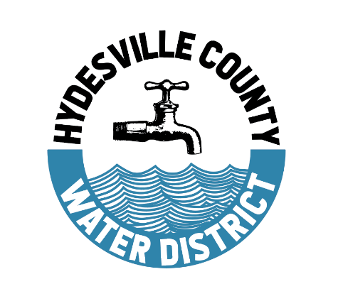
Hydesville County Water District
3455 State Highway 36 / PO Box 561
Phone: (707) 768-3000 Fax: (707) 768-1730

Water Bill Payment Plan Agreement

No one except the person whose name is currently on the account can request any action
on the account.

Name_________________________________________Phone#_______________________
eMail_______________________________________________________________________
Service Address _____________________________________________________________
Billing Address______________________________________________________________
Account #___________________ Total Amount Currently Due ____________________
Date Requested _____________ Date Account will be paid in full ______________

Payment agreement dates will not be extended beyond 12 months from the agreement date.

Per this agreement with the Hydesville County Water District you have agreed to the following items (all 3 lines must contain the requested information for request to be considered):

- Make additional payments monthly to the past due amount, due no later than
the 20th of each month, beginning on: __________________________________
B. Bring account fully up to date by: ______________________________________
C. Pay a minimum monthly payment amount of: __________________________*

Please sign below in acceptance of this agreement. Failure to make a monthly payment or comply with this contract will result in utility termination and I, the undersigned customer, hereby waive my right to receive any additional notice.

I, the customer below, understand that if this account is permitted to remain delinquent past the extended date, service will be disconnected and in addition to the full past due amount, I will owe a $40.00 reconnect fee.

Customer Signature: _____________________________________________ Date ______________
Board Member Signature: _________________________________________ Date _____________
Board Member Signature: _________________________________________Date ______________

HYDESVILLE COUNTY WATER DISTRICT PAYMENT PLAN
POLICY FOR WATER
The purpose of this policy is to provide the utility customer with a means to extend the amount of time they may need to pay their past due bills prior to service disconnect.

A payment plan will allow a customer more time to pay their past due bills. The payment schedule for payment plans will be established at the time of request but may not exceed 12 MONTHS.

Those on a payment plan will not be charged late fees so long as the scheduled payments are made.

To set up a payment plan, complete the enclosed form and bring it to the office, to have it reviewed at the next board meeting. The following rules will apply to payment plans:
- The payments must be an agreed upon amount which will bring the account current within the time period requested.

- Payments must be received prior to the 20th of each month.

- The customer is responsible for ensuring that they follow these guidelines to avoid service disconnection.

- Failure to make an agreed payment will nullify the agreement and service will be disconnected.

- If the past due amount is not paid in full on the final agreed upon due date, service will be disconnected.

- No notice will be sent to the customer prior to disconnection and the customer will be responsible for paying a $40.00 reconnection fee in addition to the full past due amount before service will be reconnected.

- To keep water service with this agreement, you must stay current with the bimonthly bill, and the payment plan amount.

h) The Board has the discretion to negotiate an extended payment plan for catastrophic cases.

*To determine your minimum monthly payment, take your average monthly bill amount and multiply it by the number of months requested. Then add that number to your current total amount due. Divide that number by the number of requested months, and that should be your minimum monthly payment amount.

We can assist you in determining what your minimum payment should be to bring your account up to date by the end of the requested time period.

Please note, our billing system is not currently able to set a billing amount other than what is due on the bills, so it is the customer’s responsibility to make the agreed upon payments.

