What is a cross-connection? What are examples of a cross-connection and why are they a problem?

A cross-connection is any actual or potential connection between the public water system and non-potable source or substance that presents a hazard to the quality of the public potable water system.

As an example: A ranch that is connected to the public water system and does not have a BPA installed has a livestock watering trough for the cows. The trough is connected to a spigot via a garden hose. Down the street there is a house fire, the fire department draws water from a hydrant to put out the fire which causes pressure to drop in the distribution system. This drop in pressure causes the water in the livestock trough to back siphon through the garden hose and into the water main. Along with the non-potable water, everything else from the trough comes with it, mosquito larva, algae, bovine saliva, dirt, and all sorts of dangerous bacteria.
This backflow event has caused the community’s shared water to no longer be safe to use.

An additional list of cross connections is listed below.
What is Backflow and how can we prevent it?

Under normal conditions, water flows from the public utility’s distribution system, through your water meter, and into residence/business.

Backflow is the undesirable reversal of this flow which has potential to contaminate the public utility’s water distribution system.

Backflow can be caused in 2 ways, through backpressure or back siphonage.

To mitigate the chances of a backflow event occurring, Backflow Prevention Devices (BPA’s) are installed on premises where cross-connections or potential cross-connections exist. These BPA’s are tested annually to ensure functionality and protection of the public water system.

Within the past few years, the California EPA along with the State Water Resources Control Board have begun to implement standards and requirements for public water systems to adopt a Cross-Connection Control Plan (CCCP.) The CCCP is a plan a water system creates as a self-guide to ensure cross-connections are identified and the public water system is protected properly.

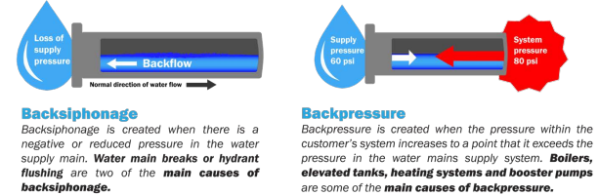
Examples of Cross-Connections
-Wells/Springs/Other sources of water -Boiler or heat pump
-Swimming pool/Hot tub -Garden hose connected to contaminants
-Underground Irrigation facilities -Water softener
-Fire sprinkler systems -Livestock troughs
-Laboratory

For any further inquiries, please contact Hydesville CWD office at (707)768-3000

