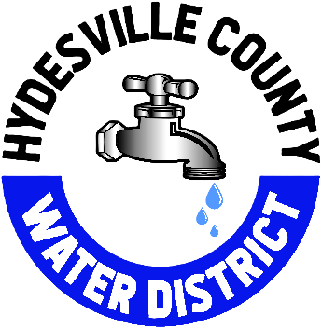 January 1, 2025

Hello Hydesville Water Customer,
Hope that you had a wonderful Holiday Season. Wanted to take a moment to remind everyone of the upcoming rate increase to the water bill, that will be coming on the February 2025 bill. This bill will reflect the increase in the base rate from $105.50 to $110.25, that was set in the last rate increase schedule. This rate increase does not have any change in the number of units that are allotted, it has been 11 units for the last year and will continue to stay at 11 units. Each unit that is used over the 11 allotted will now be $6.06 instead of $5.77 per unit. Units used above 49 will stay at $8.00 per unit.
*Please note that for the customers with more than one dwelling on a parcel, the new rate of $110.25 will be the amount that is multiplied by each dwelling.

Please reach out with any questions or concerns (707) 768-3000

Best Regards,

Megan Lowe
Board Secretary

