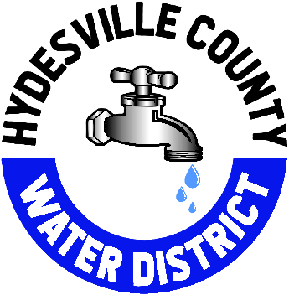

January 13, 2025
Hello Hydesville Water Customer,
Hope that the New Year is treating you well. It is that time once again, for our favorite Cross-Connection Survey. This is done once every 5 years. This is a simple form that just requires a few questions to be answered. Please note that we must receive this survey back, as it is a condition of your water service with the Hydesville County Water District.
If you do not have your account number handy, that is not a problem. Just make sure that you fill out the name and the service address on the form, so that I can correctly locate your account. Feel free to drop the survey in the drop box at the office.
Please reach out with any questions or concerns (707) 768-3000

Best Regards,

Megan Lowe
Board Secretary

