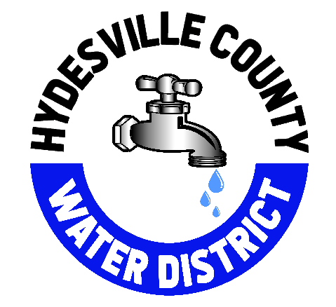
Hydesville County Water District
3455 State Highway 36 / PO Box 561
Phone: (707) 768-3000 Fax: (707) 768-1730
APPLICATION FOR WATER SERVICE

Account No. ___________________

Today’s Date: ________________ Date to Begin Service: ______________

Applicant Name: ________________________________________ D.O.B. __________________
Service Address ____________________________________________ Apt No. _____________
MailingAddress__________________________________________________________________
Social Security No. _____-___-______ Driver’s License No. ____________State ________
Phone No. (___) ___________________ Please Mark One: OWN RENT
Email Address______________________________________________________________
Co-Applicant Name: _____________________________________ D.O.B. ______________
Social Security No. _____-___-______ Driver’s License No. ___________ State ________
Phone No. (___) ___________________
Email Address_______________________________________________________________
How would like your bill sent to you? (you may choose more than one):

Post card Email Paper Statement (8.5x11)

By acceptance of service, the Applicant and Co-Applicant (when applicable) understands that he/she must comply with all policies of the Hydesville County Water District and all ordinances pertaining to water as described as well as all other local, state, and federal laws.

Please note the following:

• The Hydesville County Water District requires a refundable deposit in the amount of $200.00 for all new services. Deposits are applied to accounts after 12 months of good credit standing.
• The Applicant and/or Co-Applicant are financially responsible for all water billing and water leaks on property side of the meter. Failure to receive a bill does not excuse the responsibility to pay.
• The Hydesville County Water District requires proof of identity along with the application and deposit.
• Bills are issued on the first day of every other month and are due by the 30th of the same month. For accounts not paid by the due date, a “Reminder Notice” will be sent and, a late fee in the amount of $20.00 will be applied to the account. If the bill is still not paid, a “Disconnect Notice” will be mailed after the 25th of the next month. If past due amounts are not paid by the due date on the disconnect notice, there will be a disruption to the water and a non-refundable reconnection fee will be assessed. The past due balance, reconnect fee and a deposit (if applicable) will be due and payable prior to water reconnect.
• The Owner/Tenant/Occupant will be held liable for damaged and/or stolen meters up to and including civil and/or criminal penalties, fees and costs.
• Customers may pay, via telephone at (707) 768-3000, online through our website,by mail or in person at The Water District Office. The Hydesville County Water District accepts cash, check, debit/credit card and money orders; for faster service please bring the top portion of your bill when paying in person.

If you have any questions regarding your bill please call the office at (707) 768-300 during our regular business hours:
Monday-Wednesday- Friday 8:15 am to 12:15 pm, Tuesday-Thursday 12:15-4:15 with the exception of holidays.

Signature _______________________________________________Date ________________
Print Name _____________________________________________

Official use only: Route: ____Service: ___________ Date: ________________
W.O. # ___________ Meter NO.: _____________ Reading: Old: _______New: ______________ Office use only: Deposit Paid $ ________ Application Accepted by _____________________ Picture ID [ ] Rental Agreement/Proof of Ownership [ ]

