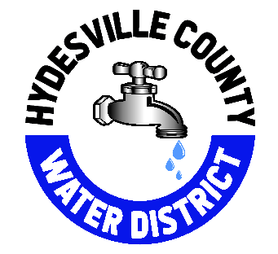
Hydesville County Water District
3455 State Highway 36 / PO Box 561
Phone: (707) 768-3000 Fax: (707) 768-1730

The Hydesville County Water District has historically maintained water rates close to or less than the average rates of surrounding communities and towns. A rate increase should be considered due to the increasing costs of materials necessary to operate and maintain the water system, as well as the system’s need for replacing aged plumbing throughout the distribution system.

In 2023, the district implemented a new rate schedule to increase the base cost and the price of additional units consumed over the base allotment by a flat 5% annually over a 3-year period, ending 2/01/2025. Additionally, the base allotment was dropped from 15 to 11 units. Over those three years, the base rate of water bills increased from $80.00 to $110.25 and the cost of units over the allotted amount from $5.00 to $6.06. This previous increase has allowed us to keep up with the maintenance of the water system and allocate additional funding for improvement projects.

The proposed rate increase will ensure that the district continues to operate on a budget that keeps ahead of inflation and rising costs, as well as allowing additional funds to be put towards critical system replacements and improvements each year.

This proposed rate increase has been structured to meet the following goals:
- Keep ahead of inflation rate so we can operate without a deficit.
- Maintain the water treatment and distribution system, to allow additional funding that improves the system’s reliability, resiliency, and longevity.
- To have a fair and reasonable rate increase while maintaining lower than average costs in comparison to other local water systems.
- Create a rate structure design that is easily understood by customers and virtually eliminating the need to keep small change on-hand, streamlining transactions.
- The rate increase would be accompanied by a revision to the district’s leak adjustment policy, decreasing the timeframe of when leak adjustments may be requested. Currently one leak adjustment is allowed every 3 years, this would be lowered to every 2 years.

There will be a public hearing on July 27, 2026, for all customers to attend. The district will answer all questions and concerns at this meeting.

Best Regards,

Jordan Stoffel
General Manager

